PHYSICS 12
INVESTIGATION 2019 30 marks

ANSWERS

Note: Mass of toy missile = 5.842 g Distance between lines on scale: 10cm (0.10m) Strobe setting: 10 Hz (0.1 sec between flashes.)

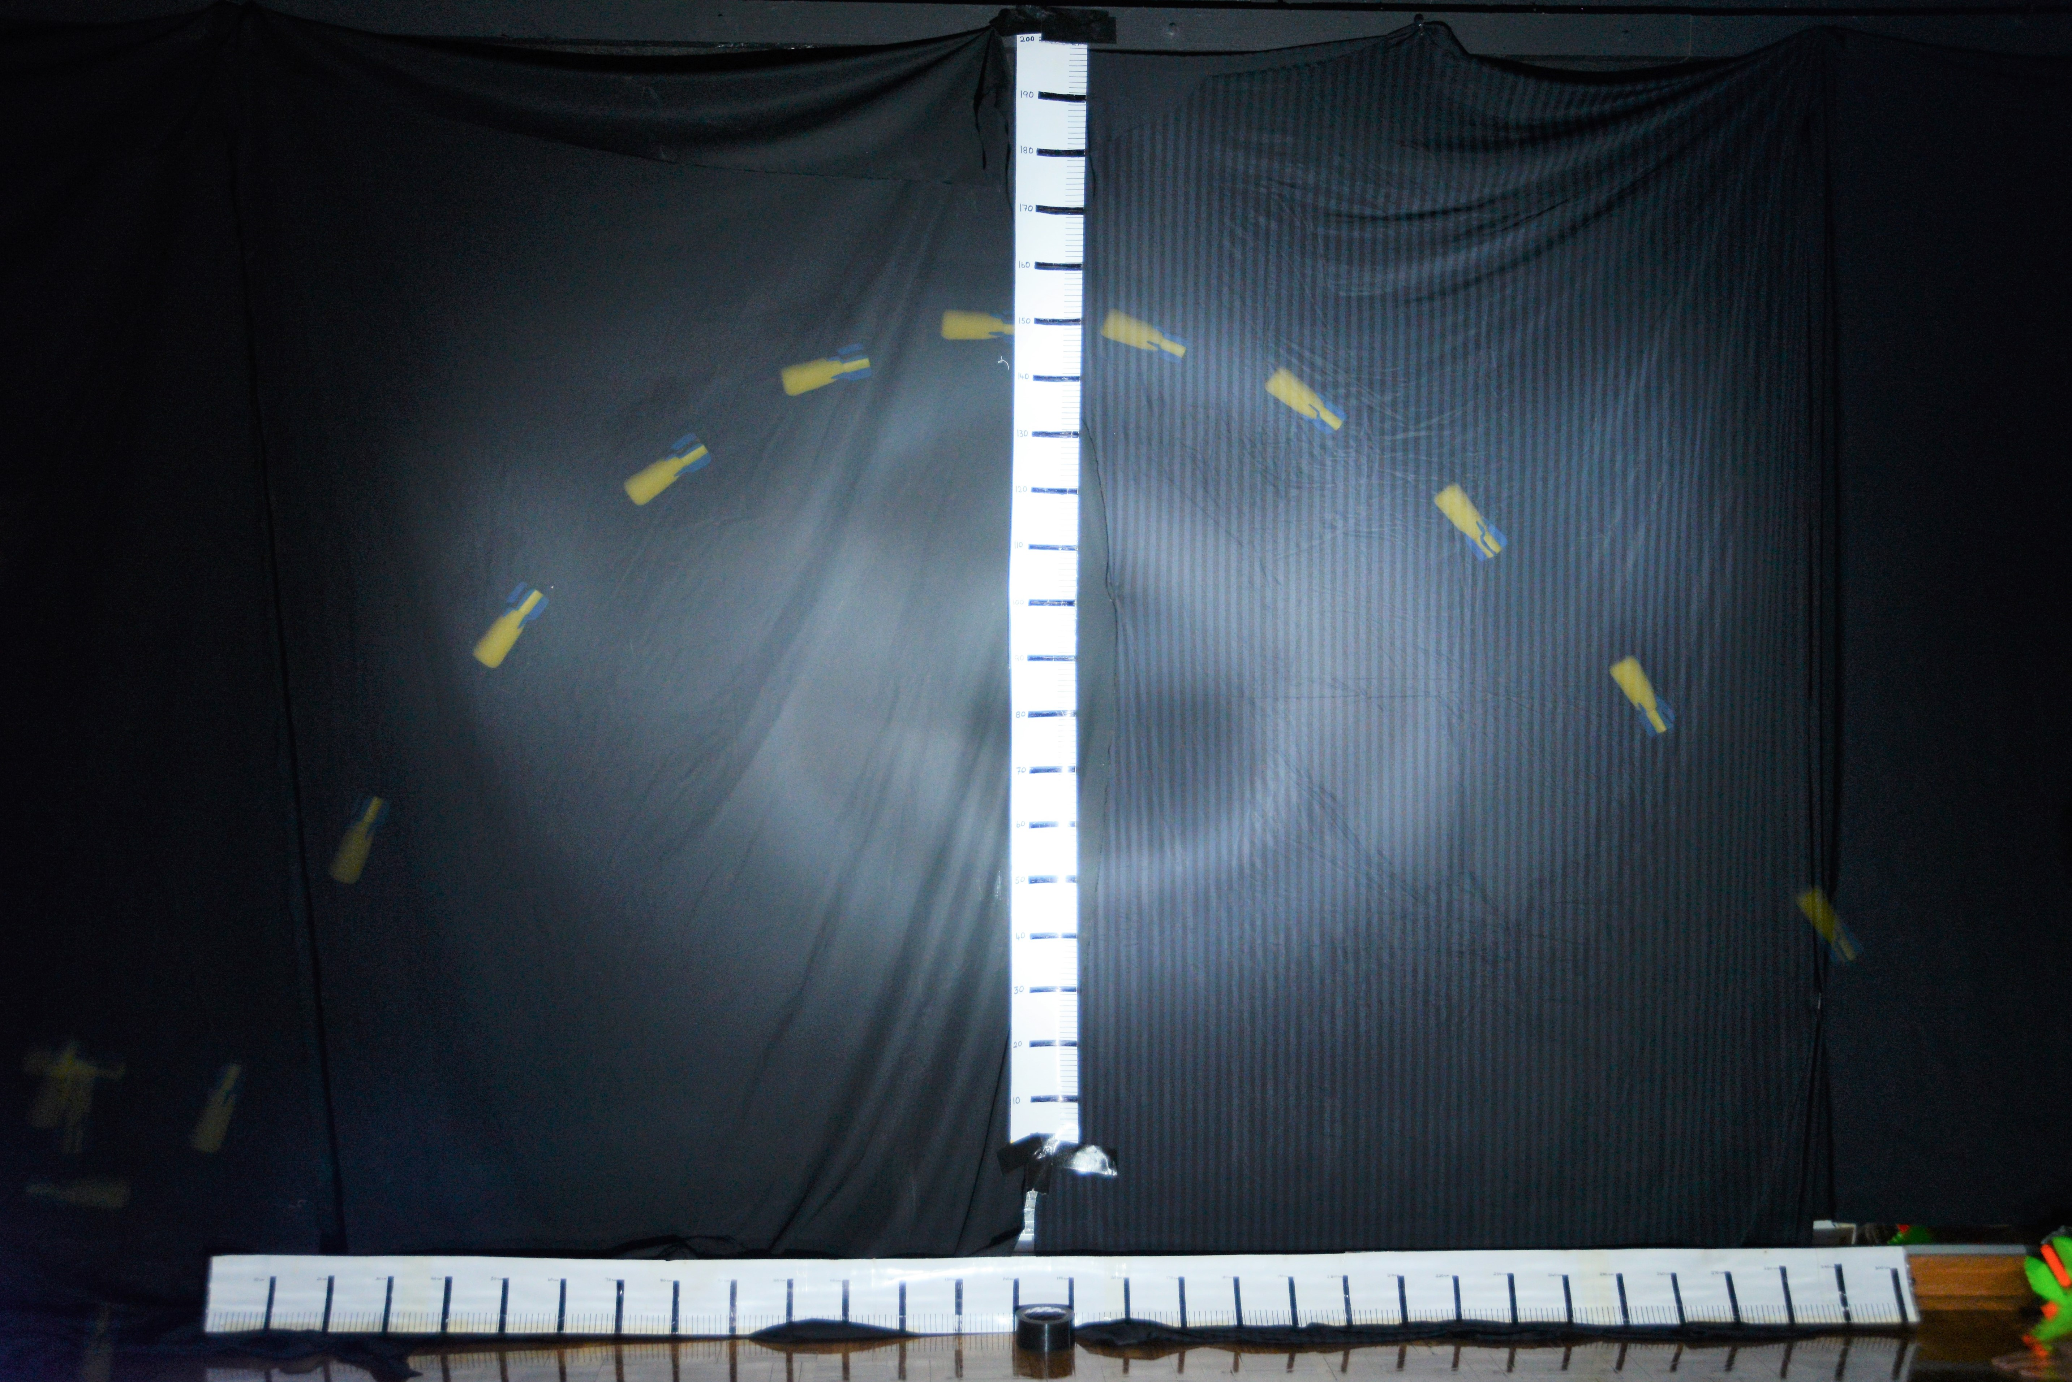

1.13m

1.50m

Total flight time = 1.0 s Total horiz. displacement = 2.83 +- 0.01 m

(2 marks)

- Determine the initial horizontal velocity of the projectile. Use the first two images. (Lines have been drawn from the top of the first projectile image). (1 mark)
U_{h} = s/t = 0.33 m / 0.1s = 3.3 ms⁻¹ (+- 0.2)

- Measure the take-off angle: 55 degrees. (+- 1) (1 mark)

- Using this value and your answer from questions 1.0 and 3.0, calculate the initial total take-off velocity (u) and hence calculate the initial vertical velocity (u_{v}). (2 marks)

U_{h} = UcosӨ so U = U_{h}/cosӨ = 3.3/cos55 = 5.75 ms⁻¹

U_{v} = UsinӨ = 5.75 sin55 = 4.71 ms⁻¹

- From your answers to questions 1.0 and 2.0, determine the theoretical range and maximum height of the projectile. (4 marks)

Theoretical range = u_{h} x t_{tot} = 3.3 ms⁻¹ x 1.0s = 3.30m (1)

Theoretical vertical height:

v² = u² + 2as (1) (Most accurate method)
0 = (4.71)² + 2(-9.8ms⁻²) s (1)
s = 1.13m (1)

NB: for this graph allow s = ut + ½at² and t = 0.5 since the answer is the same!!!

- Using your answers to 4.0, sketch the theoretical curve on top of the photograph. (1) Ht according to ans Q4, (1) Range as per ans Q 4 (2 marks)

- From the photograph, determine the final horizontal velocity of the projectile.
(Use the last two images on the left). (1 mark)

v_{H} = 0.24m / 0.1s = 2.4ms⁻¹

- Using u_{h} and your answer from 6.0, calculate the change in horizontal velocity and hence the average horizontal deceleration over the total time of the flight
(2 marks)

∆v = 2.4 – 3.3 = -0.9 ms⁻¹ (1)

a_{H} = -0.9ms⁻¹ / 1.0 s = -0.90 ms⁻² (1)

- Using your answer to 7.0, calculate the retarding horizontal force on the projectile. Express your answer to the appropriate number of significant figures. (4 marks)

F_{H} = 0.90 ms⁻² x 0.005842 kg = 5.3 x 10⁻³ N RIGHT
(1) (1) Dir’n (1)

2 sig figs (1)

- From the photograph, estimate the “final” vertical velocity of the projectile (use the last two images on the left).
(1 mark)

∆v = 0.49m / 0.1s = 4.9 ms⁻¹

- Using the initial vertical velocity as zero, your answer from 9.0 and the displacement from the highest point to the last image, calculate the downward acceleration on the projectile while it is falling.
(2 marks)

s = 1.50m v² = u² + 2as
(-4.9)² = 0 + 2a(1.50)
a_{v} = - 8.00 ms⁻² Down

- Knowing that the downward acceleration should be 9.8 ms⁻², from your answer to 10.0, calculate the upward force on the projectile due to air friction
Express your answer to the appropriate number of significant figures (4 marks)

∆a = 9.8 – 8.00 = 1.80 ms⁻² up (1)

F_{V} = ma = 1.80 x 0.005842 kg = 1.0 x 10⁻² N UP
(1) Dir’n (1)

2 sig figs (1)

- Using the photo below, determine Ramtin’s average speed. (4 marks)

Show on the photo from where you have taken your measurements.
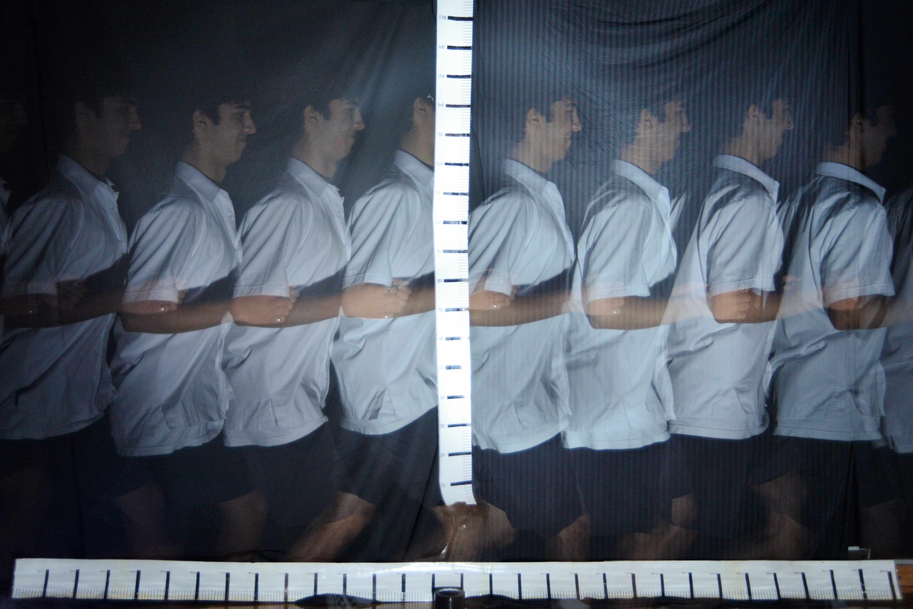

S= 2.72 m t = 0.70 s V = s/t = 3.88 ms⁻¹

1 mark: lines shown with at least 4 images (0.4s),
1 mark: time
1 mark: value of s
1 mark: ans +- 0.1

